eDCU Lifetime Tester
LTT Data Analyzer Installation User Manual
Document ID: 23-10-051-VTI-CCAIC-UM
Rev.: 1.0
Safran Data Systems Pvt Ltd
 | Name | Signature | Date
Prepared By | Ananth A
Reviewed By | Prabhakar T J
Approval By | Midhunseelan O S

Customer
 | Name | Signature | Date
Reviewed By | Abhay Kumar
Approved By

Document ID | 23-10-051-VTI-CCAIC-UM
Document Name: | LTT Data Analyzer Installer User Manual
Document No.: | R/PP-03/25
Project/Product Name: | eDCU Lifetime Tester
Project/Product Code: | 23-10-051-VTI-CCAIC
Revision Status: | 2.0

Change Summary

Release No. | Date | Changed By | Change Description
Version 1.0 | 09-01-2024 | Ananth A | Initial Version
Version 1.1 | 04-02-2024 | Abhay Kumar | Review and Add Prerequisite, where to get the installer and better regrouping of the content

Contents
1 Prerequisite for the Installation 6
1.1 System Requirements 6
1.2 Software Dependencies 6
1.3 User Permissions 6
1.4 Optional Recommendations: 6
2 Installation Of LTT Data Analysis Tool 6
2.1 Getting the Installer 6
2.2 Launching the Setup 7
2.3 Installer Destination Directory 8
2.4 Adding or Changing: 8
2.5 Installation Complete 9
3 Installation of Additional Required Tools 10
3.1 MySQL Installation 11
3.1.1 The Mandatory MySQL Installer Upgrade 11
3.1.2 MySQL Choosing a Setup Type 12
3.1.3 MySQL Path Conflicts 13
3.1.4 MySQL Installation 13
3.1.5 MySQL Installation In progress: 14
3.1.6 MySQL Installation Complete 14
3.1.7 MySQL Product Configuration 15
3.1.8 MySQL Installer Type and Networking 15
3.1.9 MySQL Installer Authentication Method 16
3.1.10 MySQL Installer Accounts and Roles 17
3.1.11 MySQL Windows Service 17
3.1.12 MySQL Apply Configuration 18
3.1.13 MySQL Apply Configuration In progress 18
3.1.14 MySQL Apply Configuration Finish 19
3.1.15 MySQL Router Configuration 19
3.1.16 MySQL Connect Server: 20
3.1.17 MySQL Connect to Server Finish 21
3.1.18 MySQL Apply Configuration 21
3.1.19 MySQL Apply Configuration Finish 22
3.1.20 MySQL Product Configuration 22
3.1.21 MySQL Installation Complete 23
3.1.22 Post MySQL Installation Completion 23
3.2 MySQL Connector ODBC Installation 24
3.2.1 MySQL Connector ODBC – Setup Wizard: 24
3.2.2 MySQL Connector ODBC – License Agreement: 24
3.2.3 MySQL Connector ODBC – License Agreement: 25
3.2.4 MySQL Connector ODBC – Setup Wizard- Setup Type: 25
3.2.5 MySQL Connector ODBC – Setup Wizard Install: 26
3.2.6 MySQL Connector ODBC – Setup Wizard-Completed: 26
3.2.7 Post MySQL ODBC Installation Completion 27

Prerequisite for the Installation

System Requirements
- Operating System:
  - Windows 10 or later
- Hardware Requirements:
  - Minimum 4 GB RAM (8 GB recommended)
  - Minimum 2 GHz Processor (Quad-core recommended)
  - At least 5 GB free disk space

Software Dependencies
- None

User Permissions
- Administrative privileges are required for installation.

Optional Recommendations:
- 16 GB RAM for better performance.
- SSD storage for faster loading times.

Installation Of LTT Data Analysis Tool

Getting the Installer
- Get The Installer from the shared drive. 01_LTT_Data_Analysis_Tool

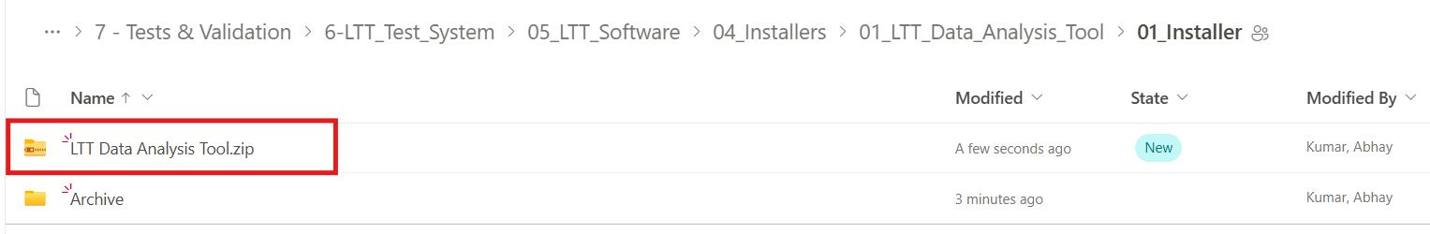
- Download the zip file
- Unzip after the download

Launching the Setup
Select the “Data Analyser Tool Installer.exe” and Right click to Run as Administrator.
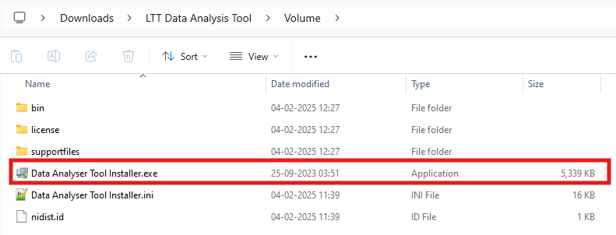
Right Click on The Setup
and Run as Administrator
Add your details and click OK.
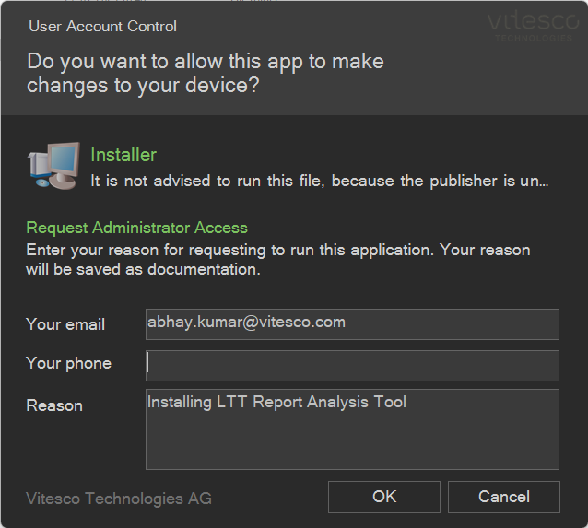

Installer Destination Directory
- Click the “Next”
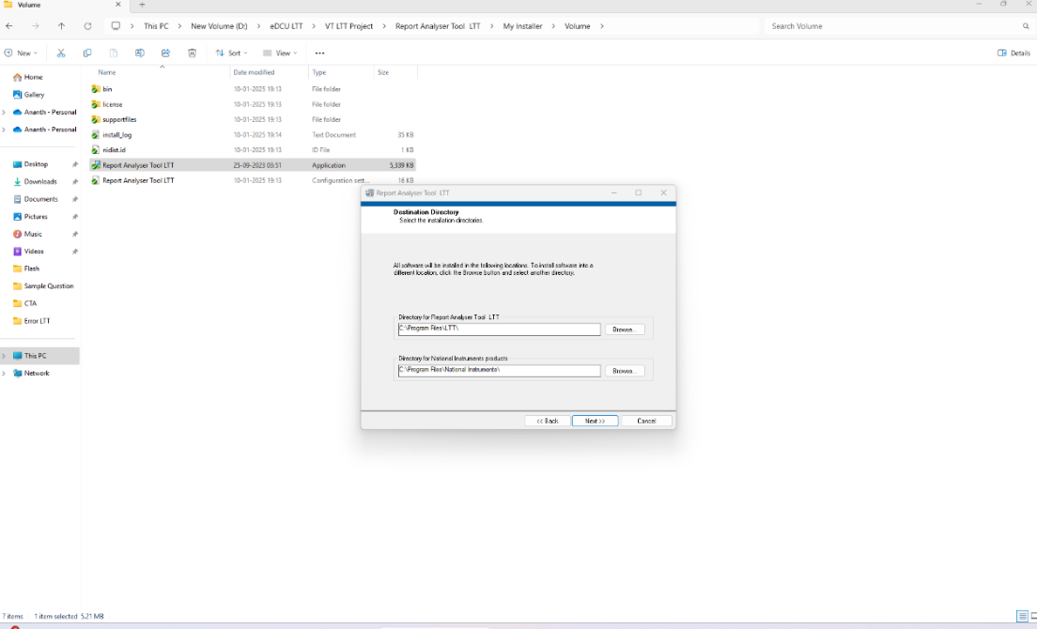
Click the Next

Adding or Changing:
- Click “Next”.
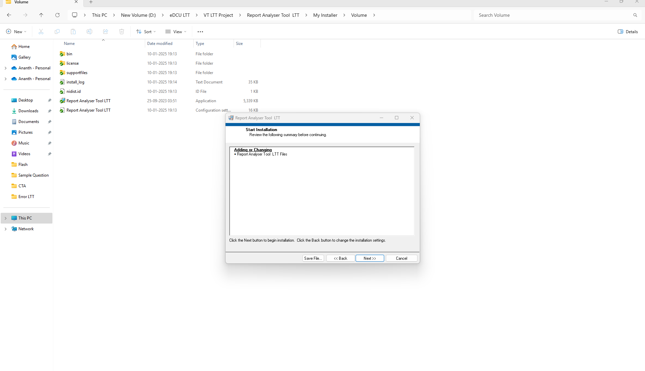
Click the NEXT

Installation Complete
- Installation completed screen below the user screen will appear. Click “Next”.
Click the Next

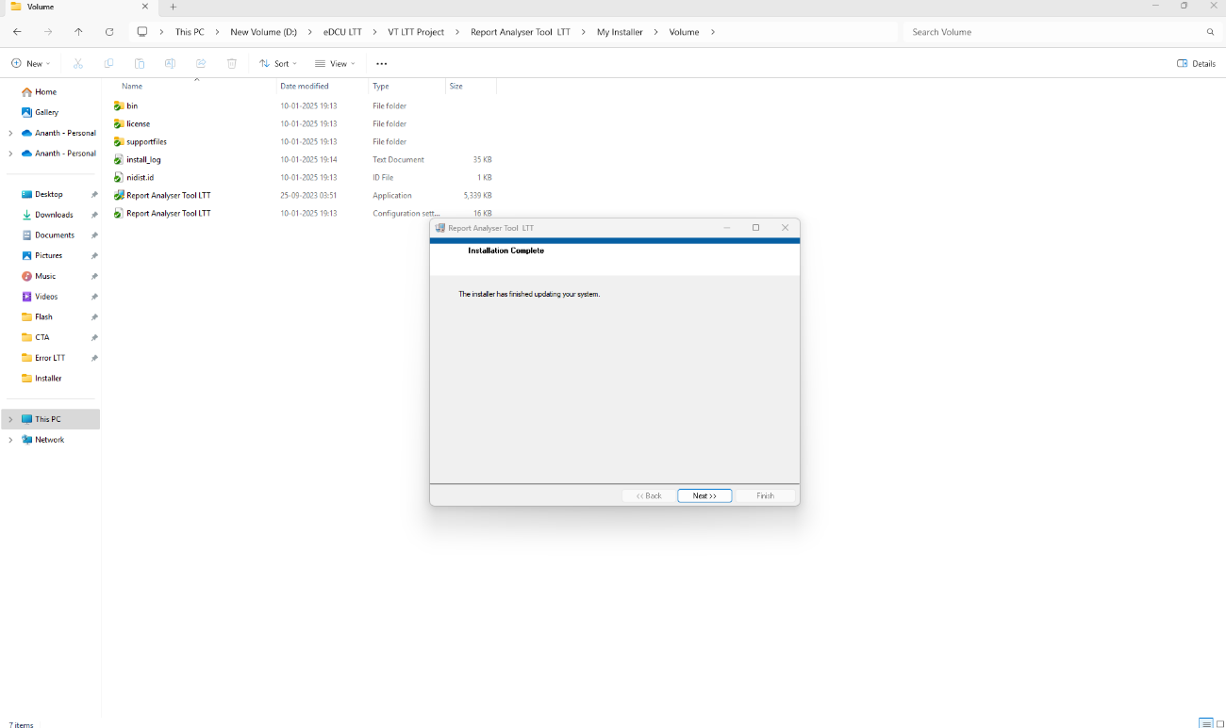

Installation of Additional Required Tools
- Once the LTT Data Analysis tool is installed the process of installing additional tools will be start.
- First It will Install MySQL followed by MySQL ODBC
- You will see the Command prompt running.
- MySQL Installer-Community screen as shown below will appear. “Running In progress”.
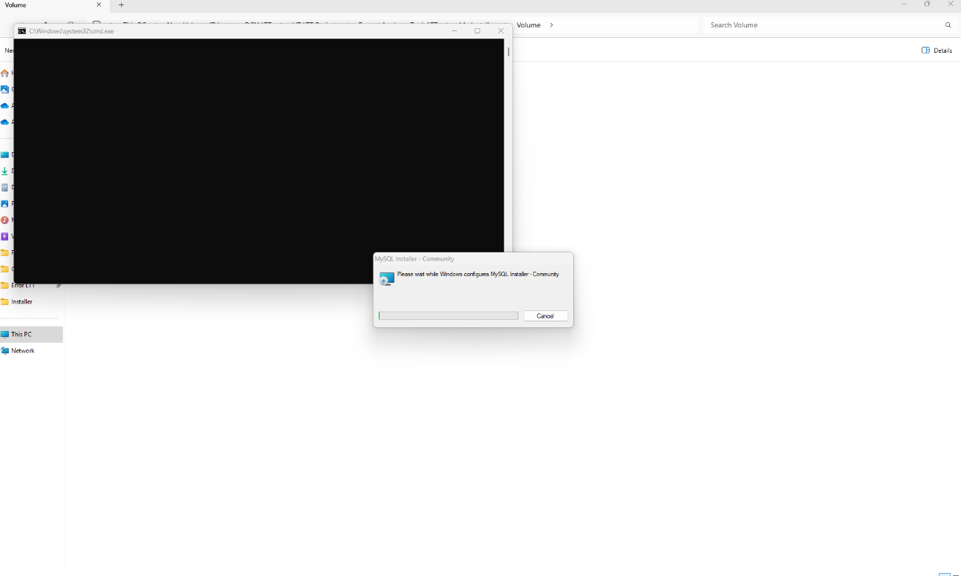
MySQL Installer Running “Please Wait the while Progress”

MySQL Installation

The Mandatory MySQL Installer Upgrade
- Click on “Yes”.
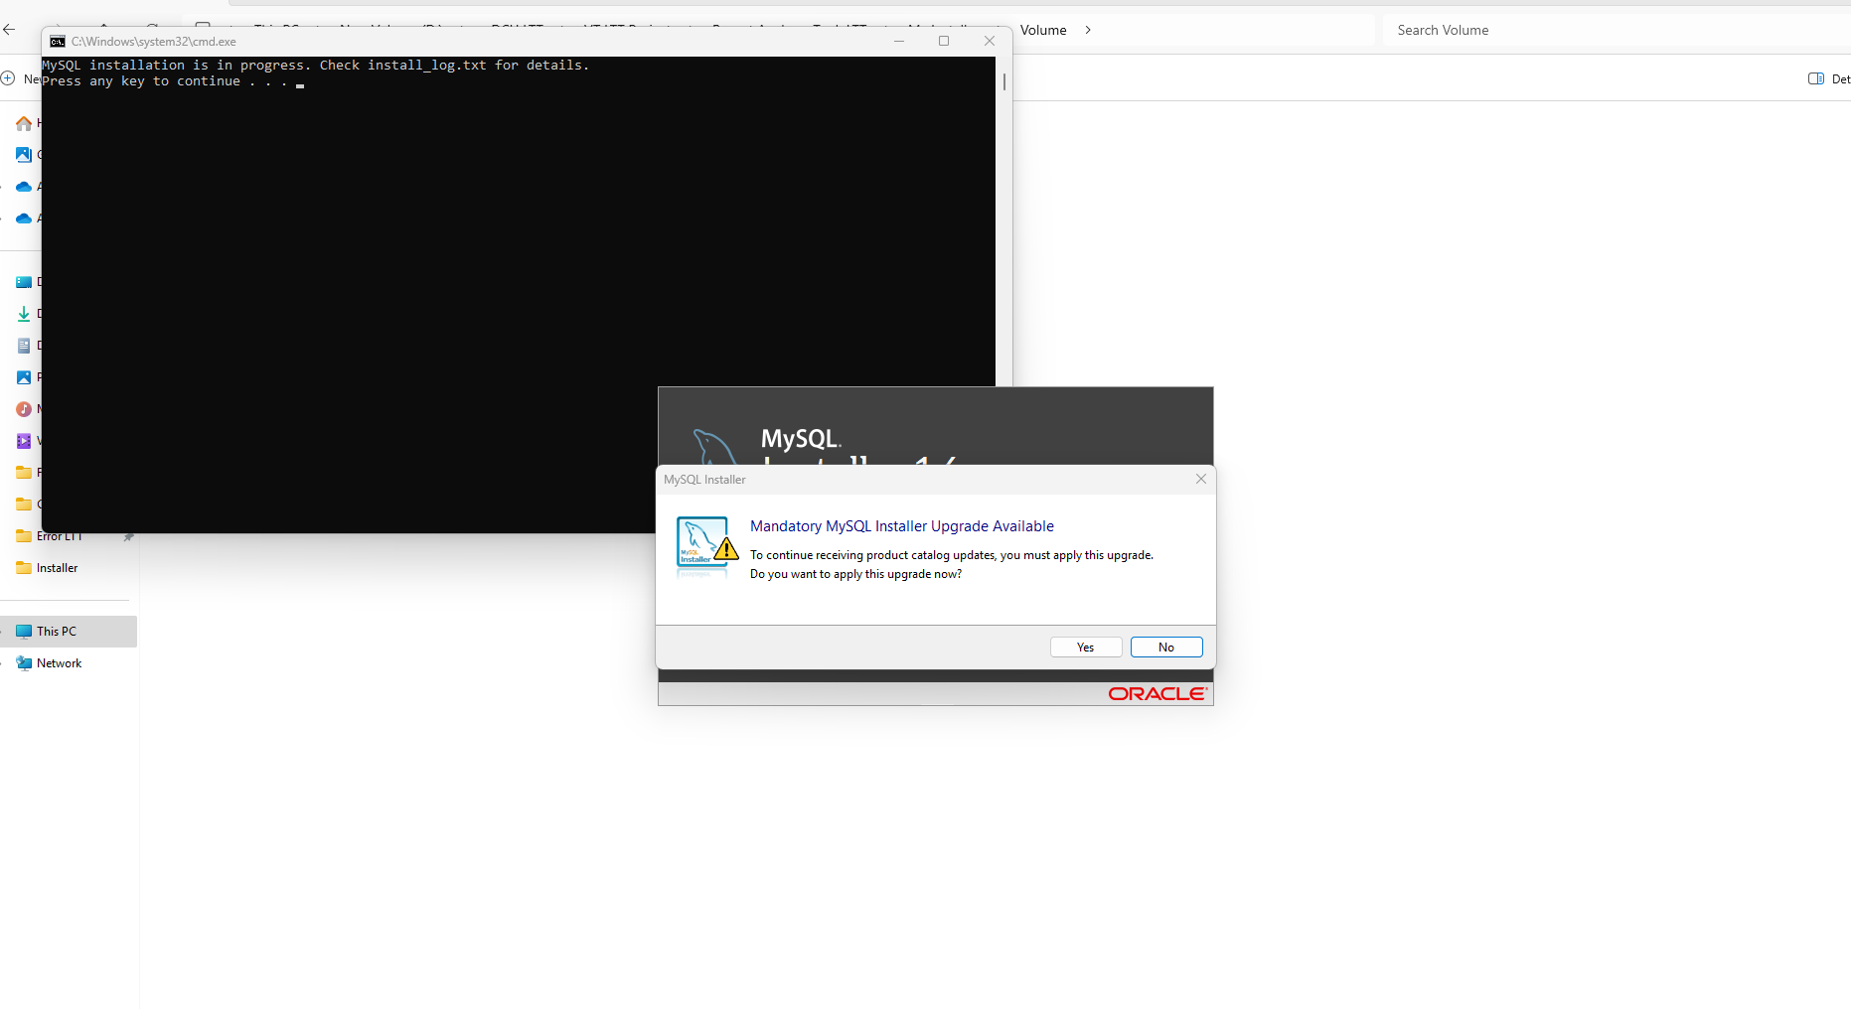
Click “Yes” button.

MySQL Choosing a Setup Type
- Tick the “Full” and click on “Next”.
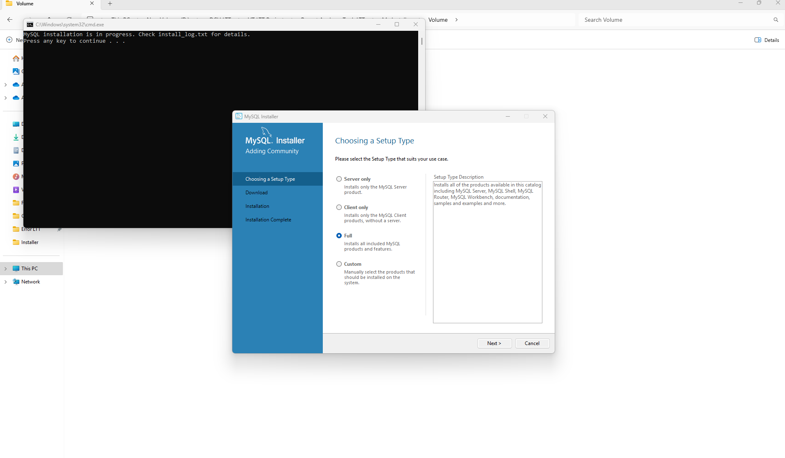
Click “Next”.
Select the “Full”.

MySQL Path Conflicts
- Keep default settings and click on “Next”.
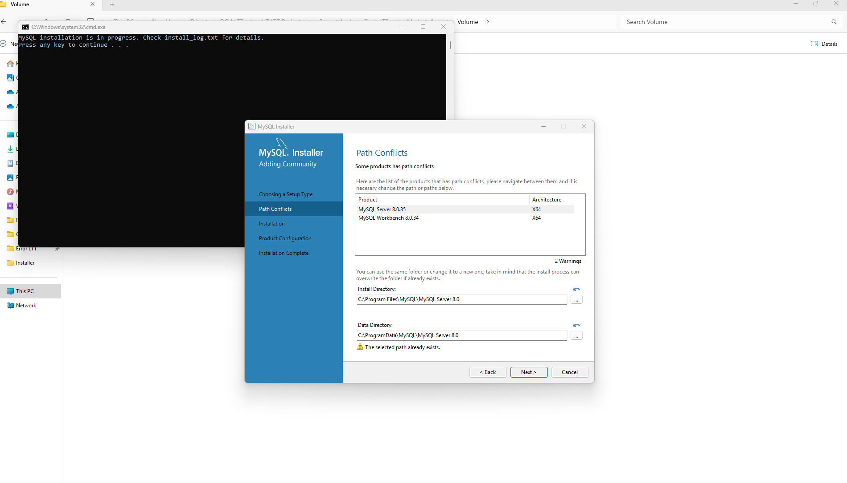

MySQL Installation
- Click on “Execute”
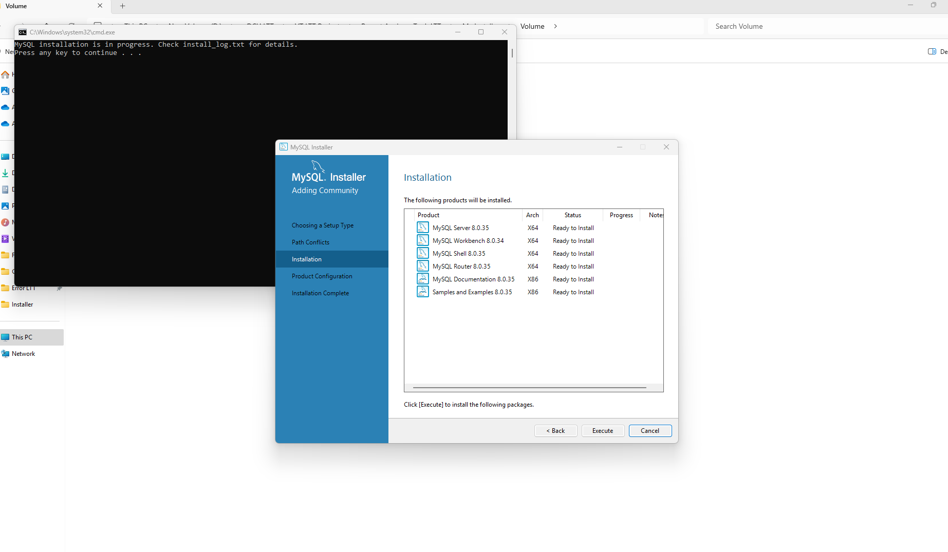
Click the “Execute”.

MySQL Installation In progress:
- Please wait until completion.
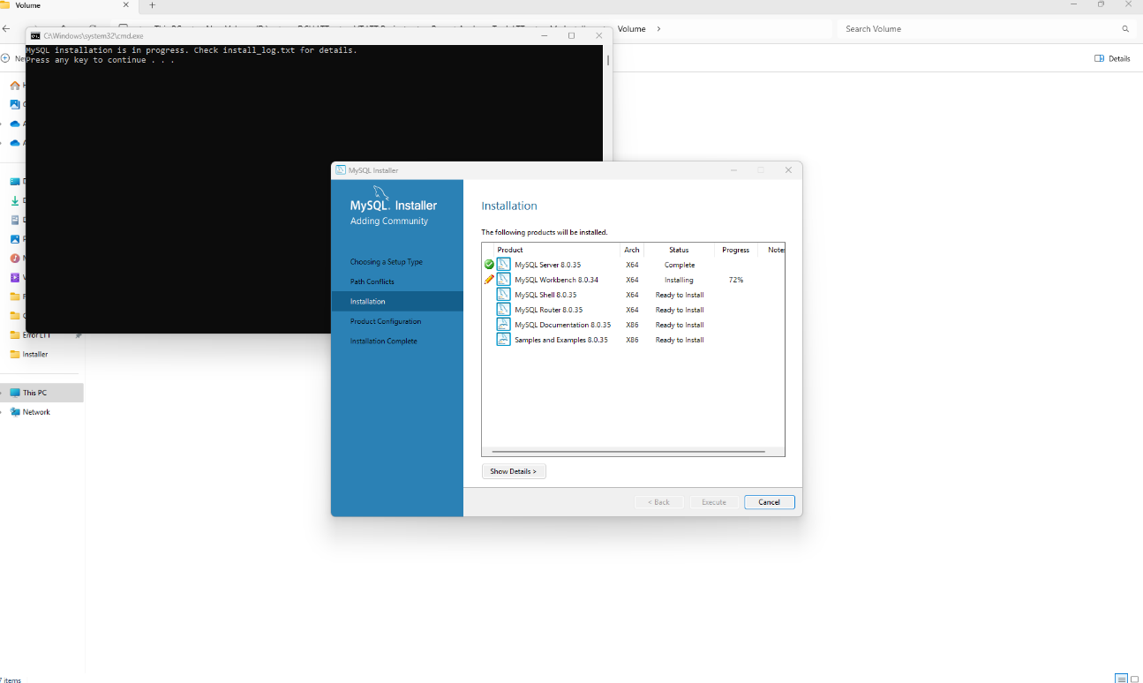

MySQL Installation Complete
- Click on “Next”.
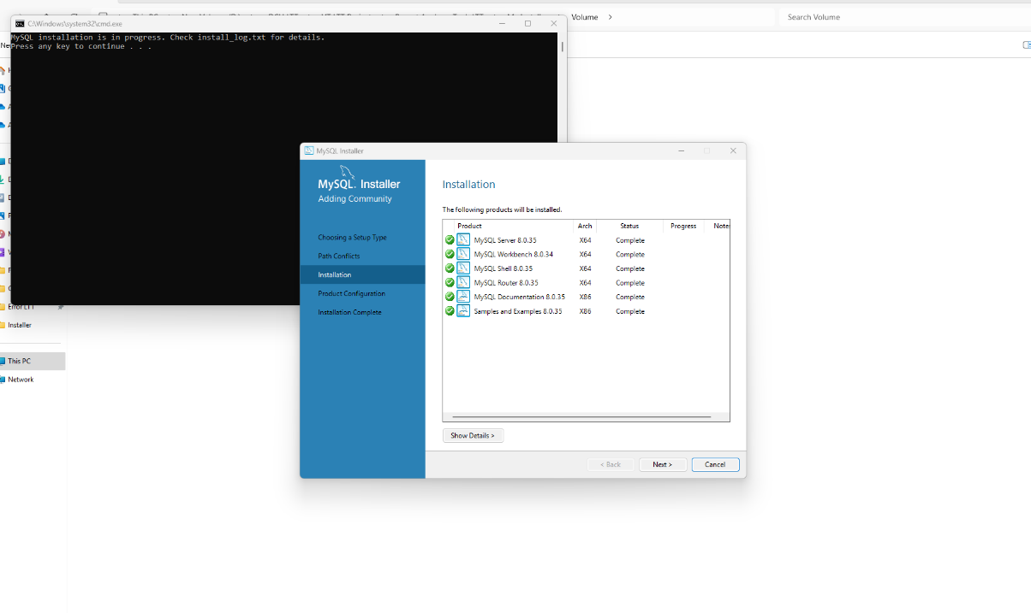

MySQL Product Configuration
- Click On “Next”.
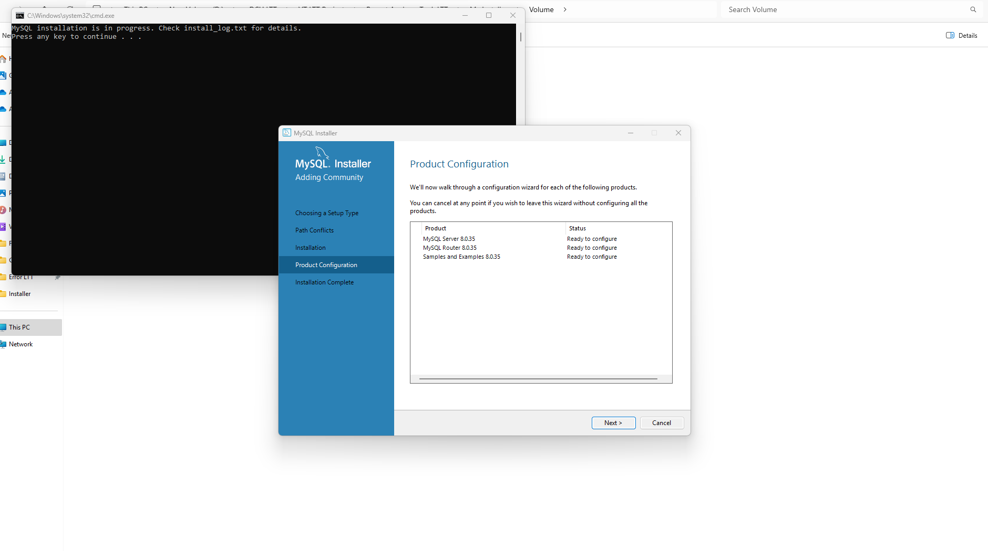

MySQL Installer Type and Networking
- Keep default settings and click on “Next”.
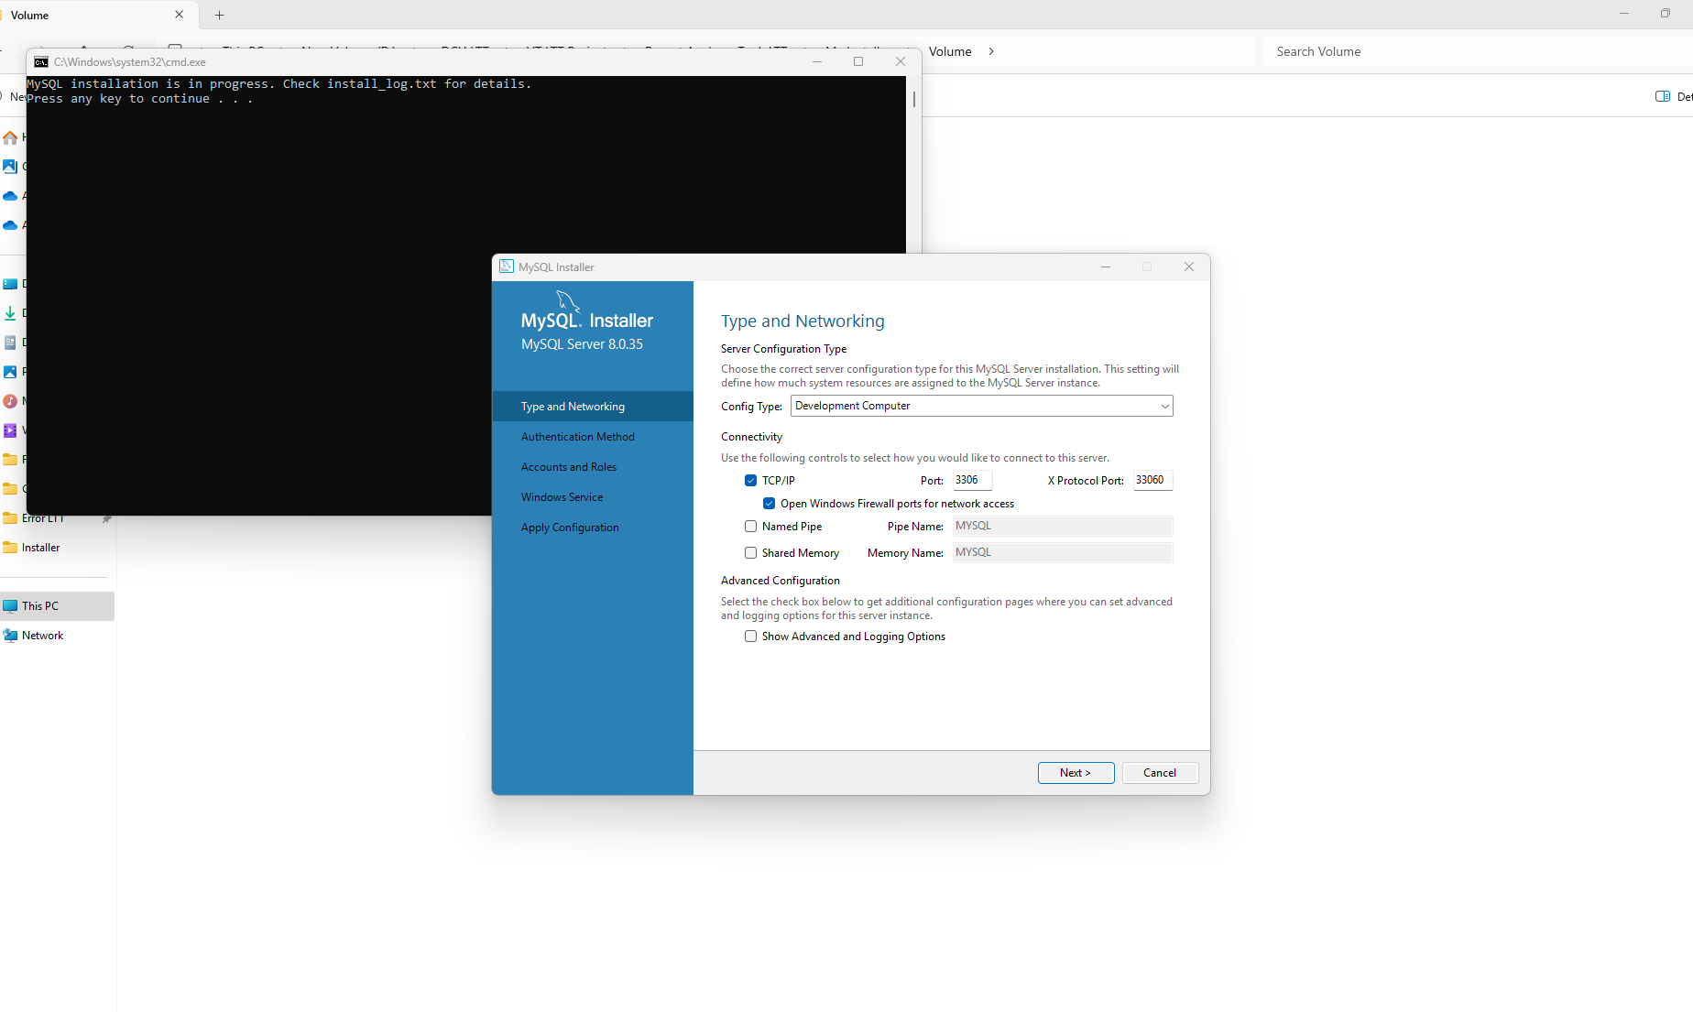

MySQL Installer Authentication Method
- Tick the “Use Strong Password Encryption for Authentication and Click on “Next”.
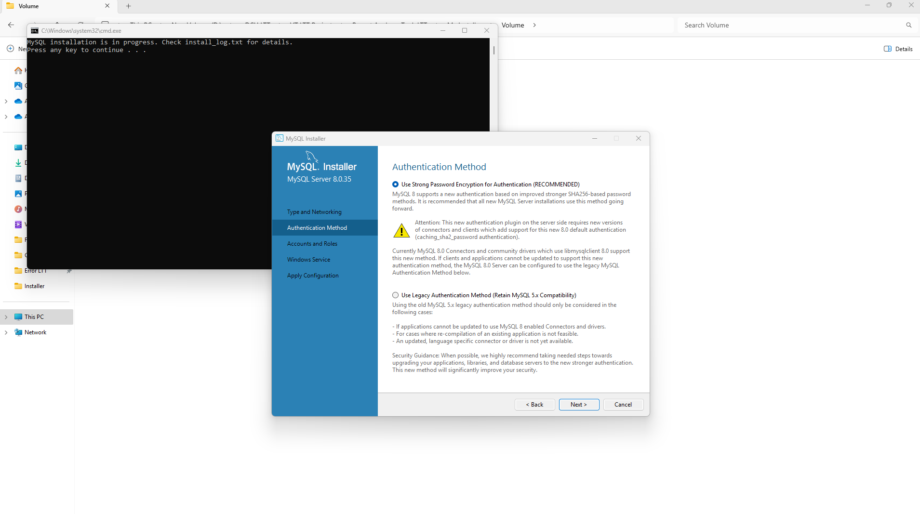
Click the Next
Select the default for Use Strong Password

MySQL Installer Accounts and Roles
- This Screen may appear different for you.
- Enter the Password “VTLTT” and click the “Check” Password or Conform the Password then Click the “Next”.
Click the “Next”
Click the “Check”
Password is the “VTLTT”
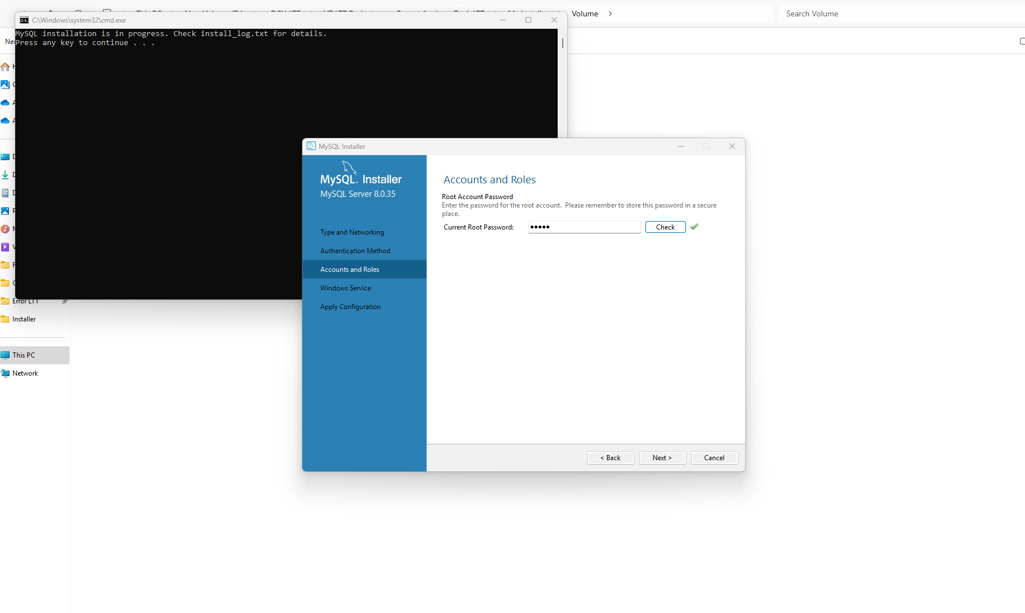

MySQL Windows Service
- Keep default settings and click the “Next”.
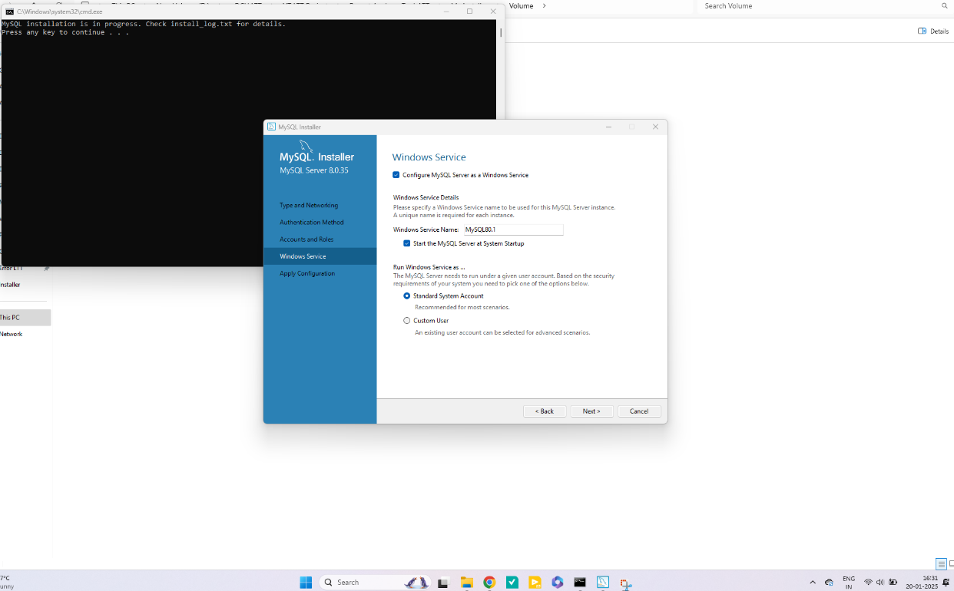

MySQL Apply Configuration
- Click on “Execute”
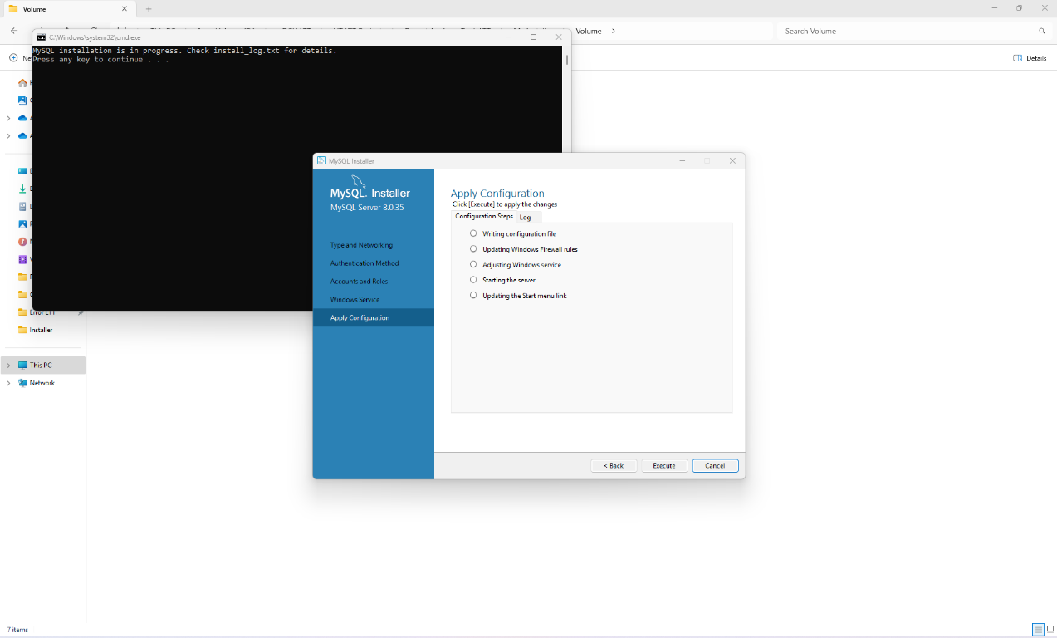

MySQL Apply Configuration In progress
- MySQL Apply Configuration in progress
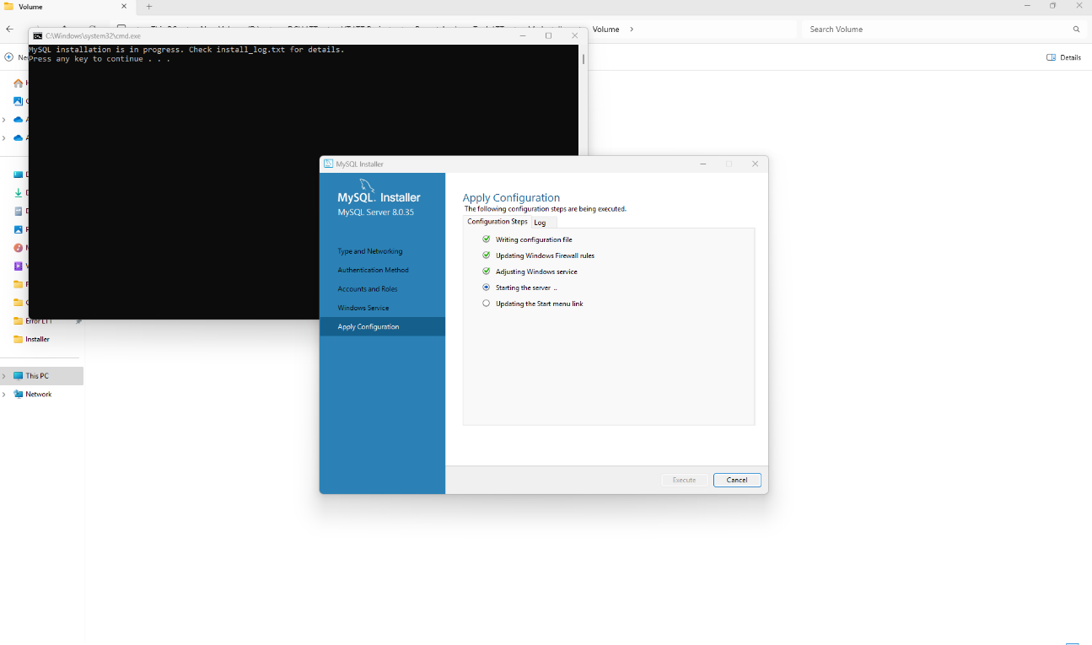
Executing in progress

MySQL Apply Configuration Finish
- Click on “Finish”.
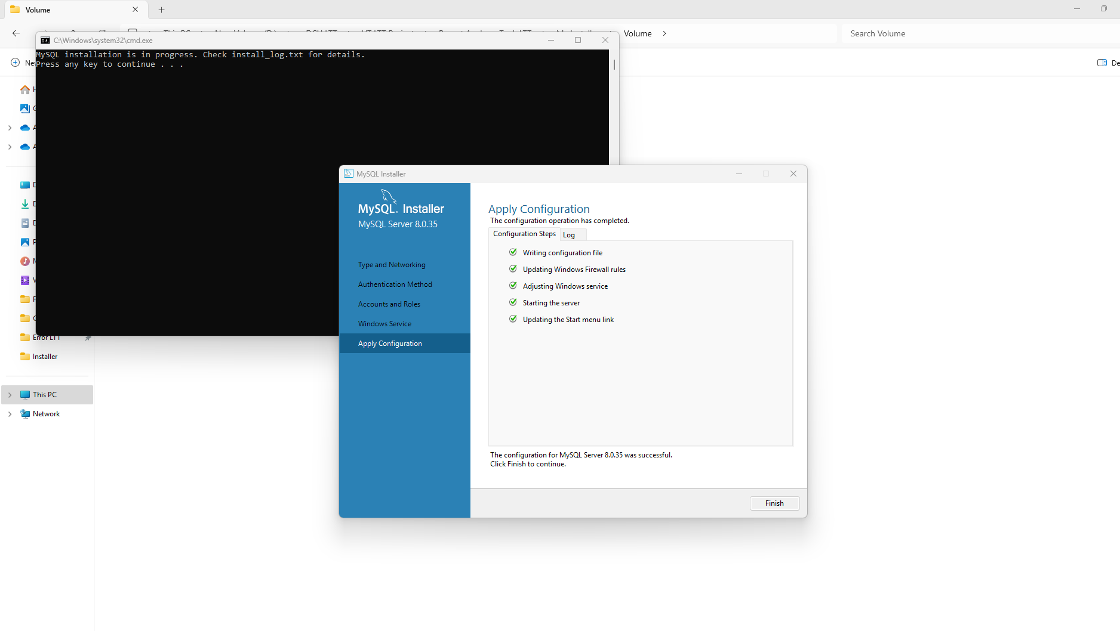

MySQL Router Configuration
- Keep the default setting and click on “Finish”.
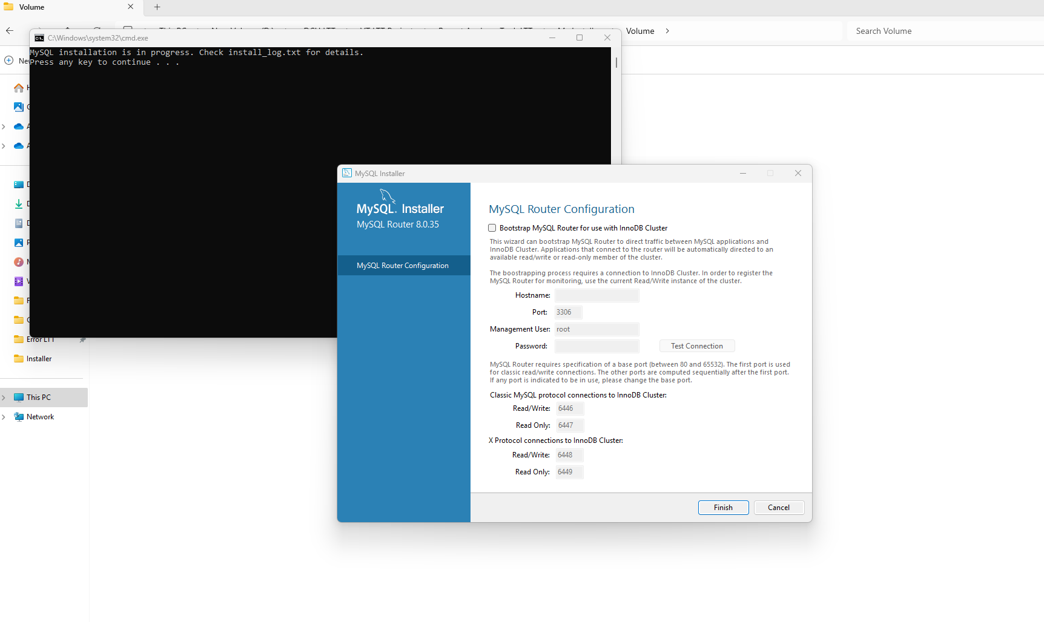

MySQL Connect Server:
- Enter the User and Password and Check the Click the “Next”.
- Username: root [Default].
- Password: “VTLTT”.
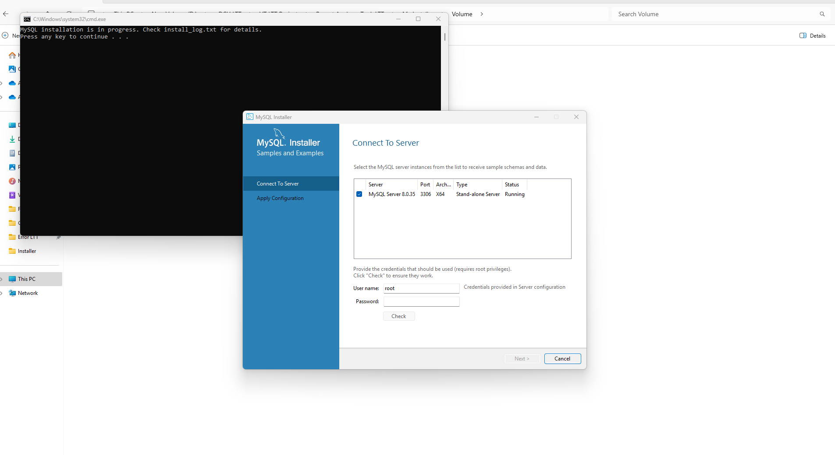
Click the “Check”
Password “VTLTT”

MySQL Connect to Server Finish
- Click on button “Check” and “Next”
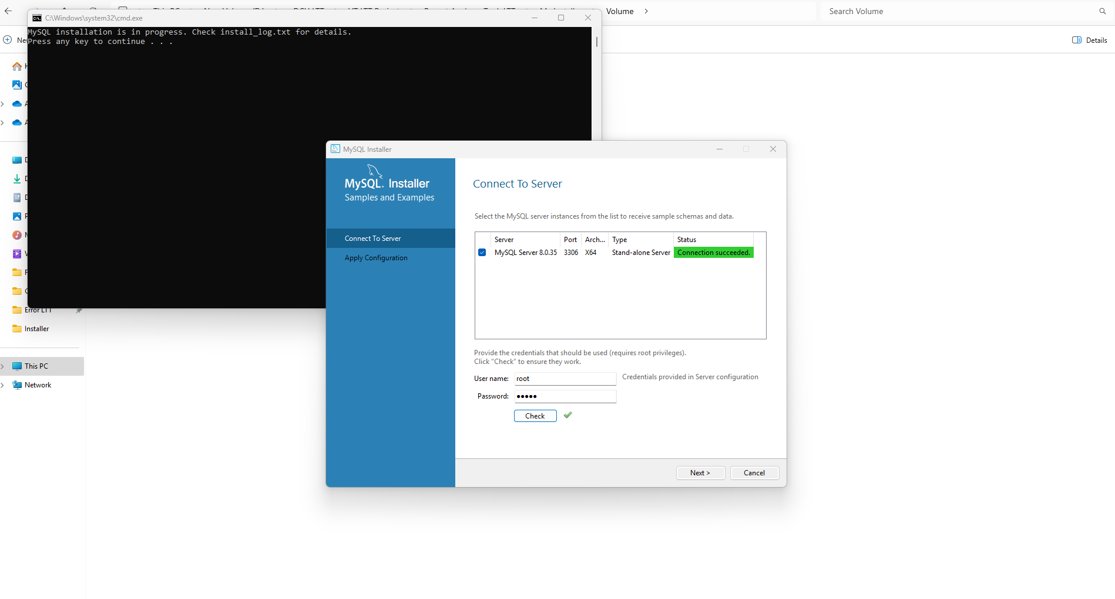
Click the “Next”
Connection Success Symbol
Connection succeeded

MySQL Apply Configuration
- Click on “Execute”
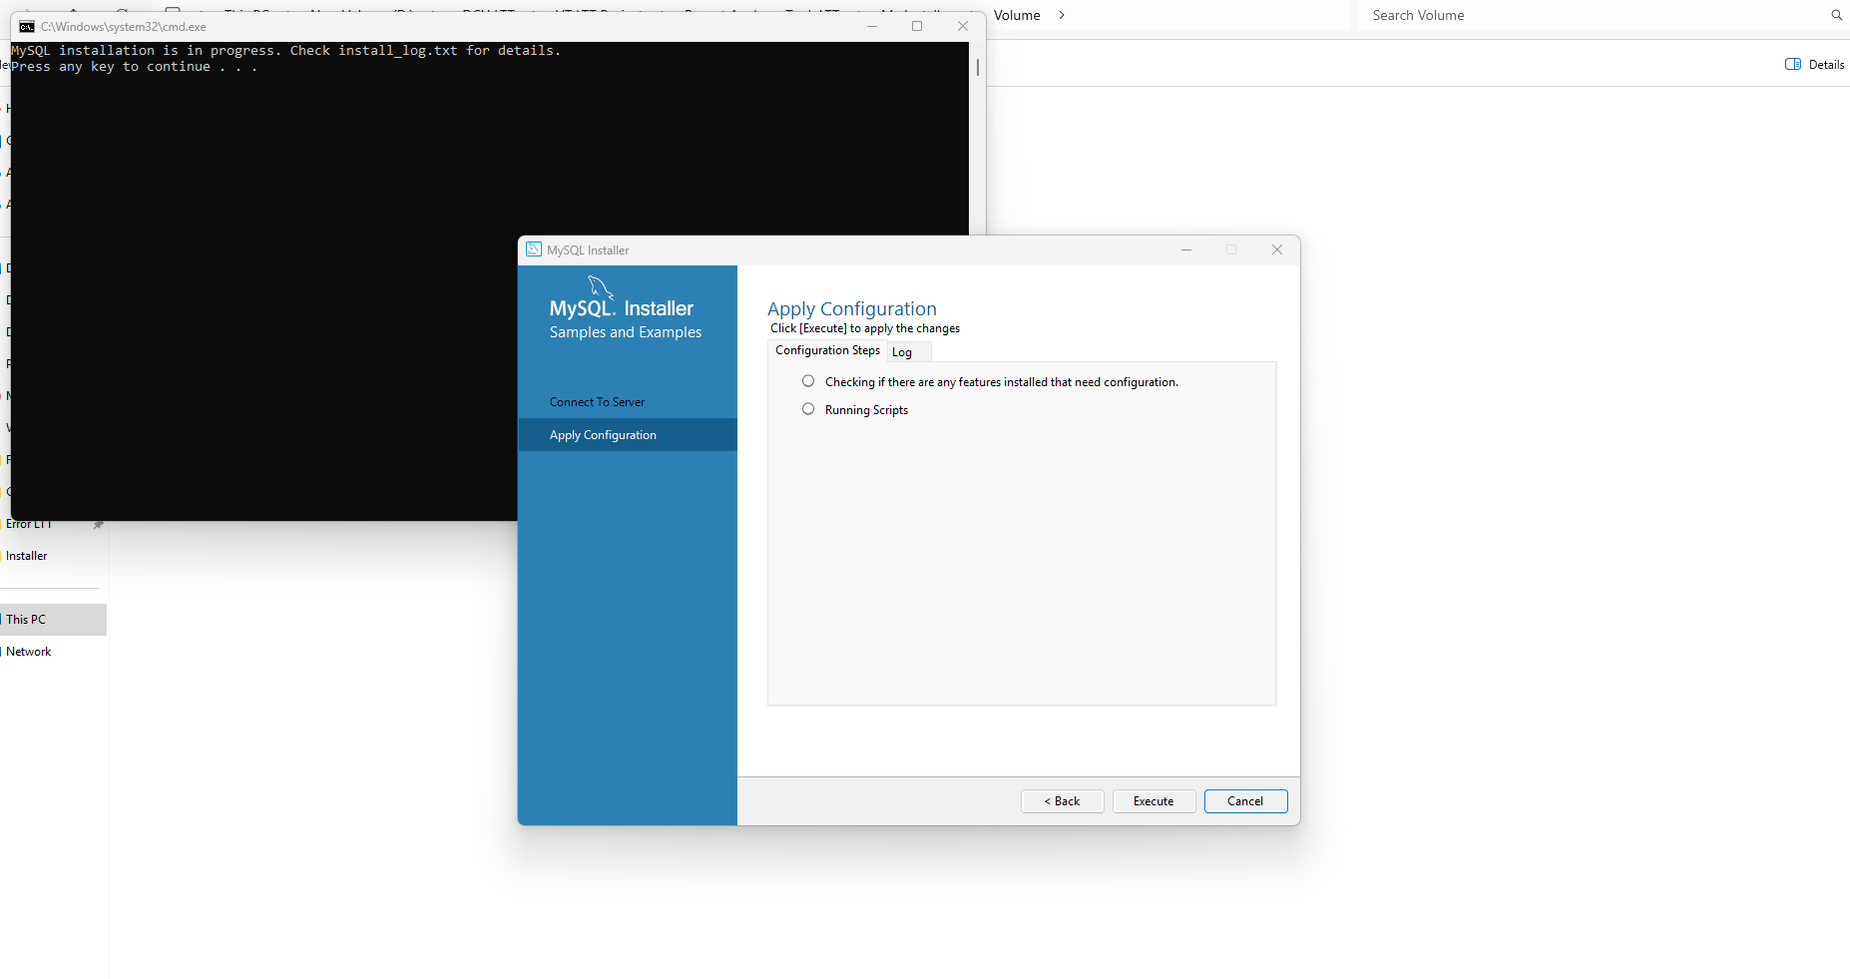

MySQL Apply Configuration Finish
- Click on “Finish”.
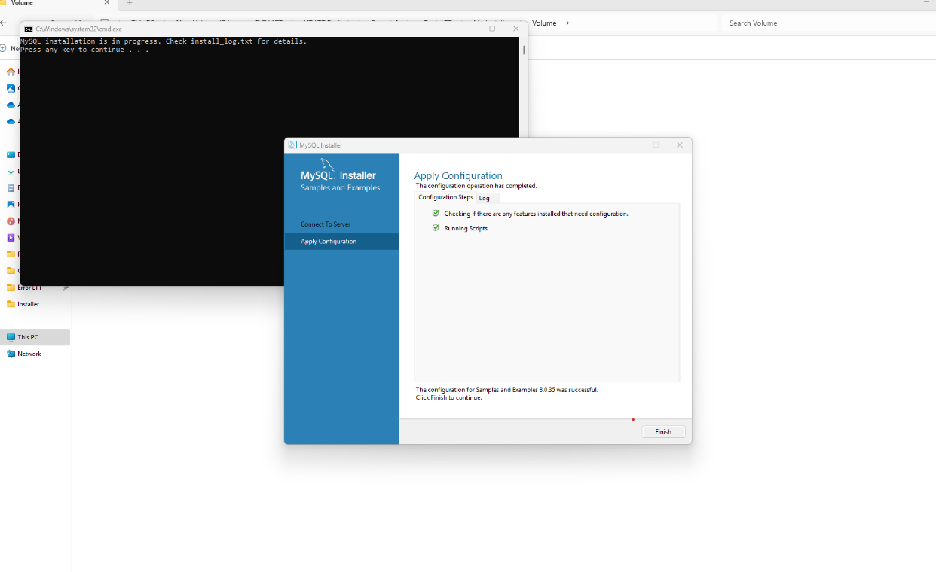

MySQL Product Configuration
- Click on “Next”
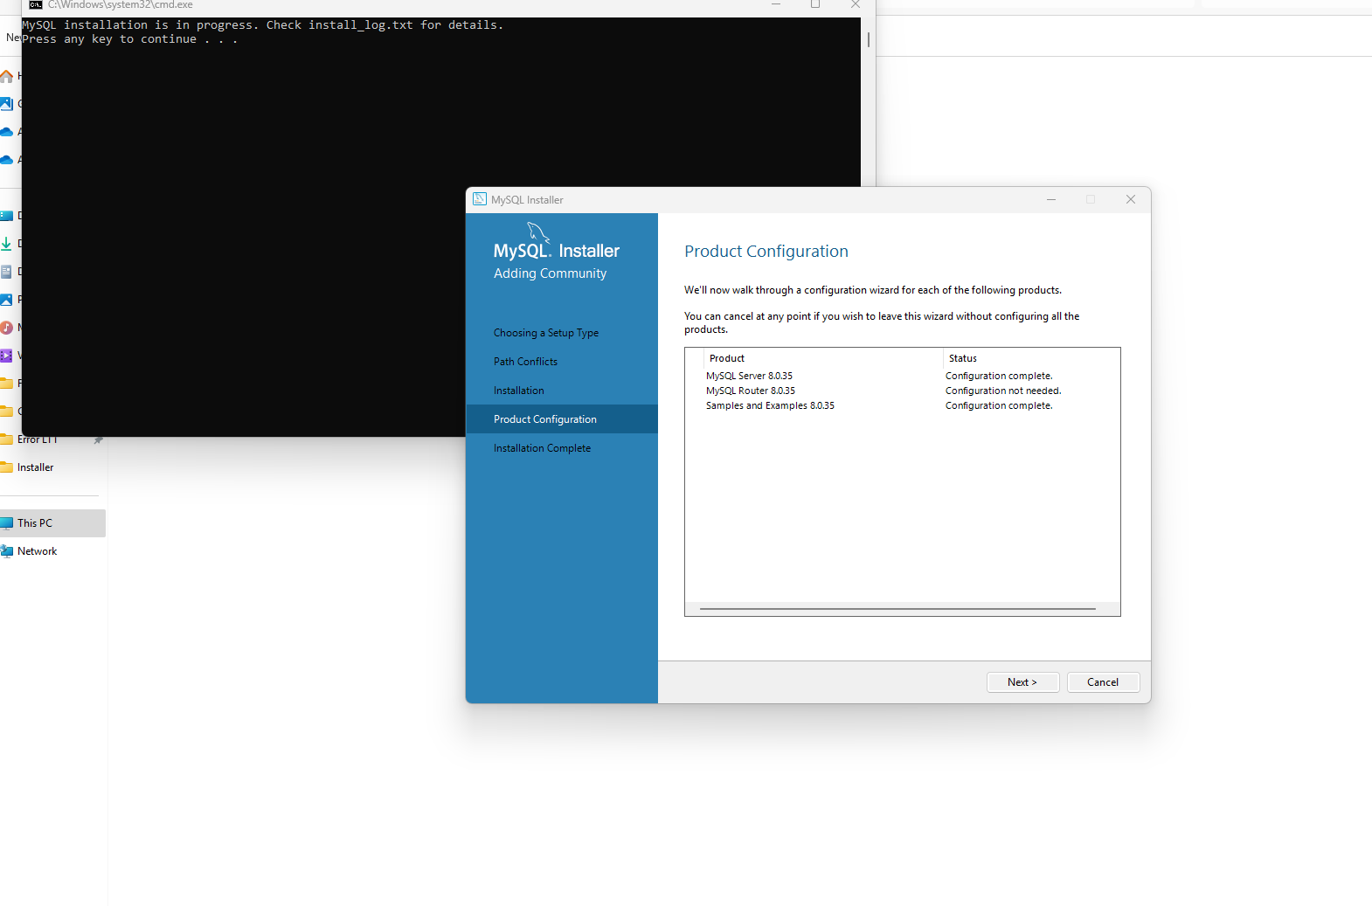

MySQL Installation Complete
- Click on “Finish”.
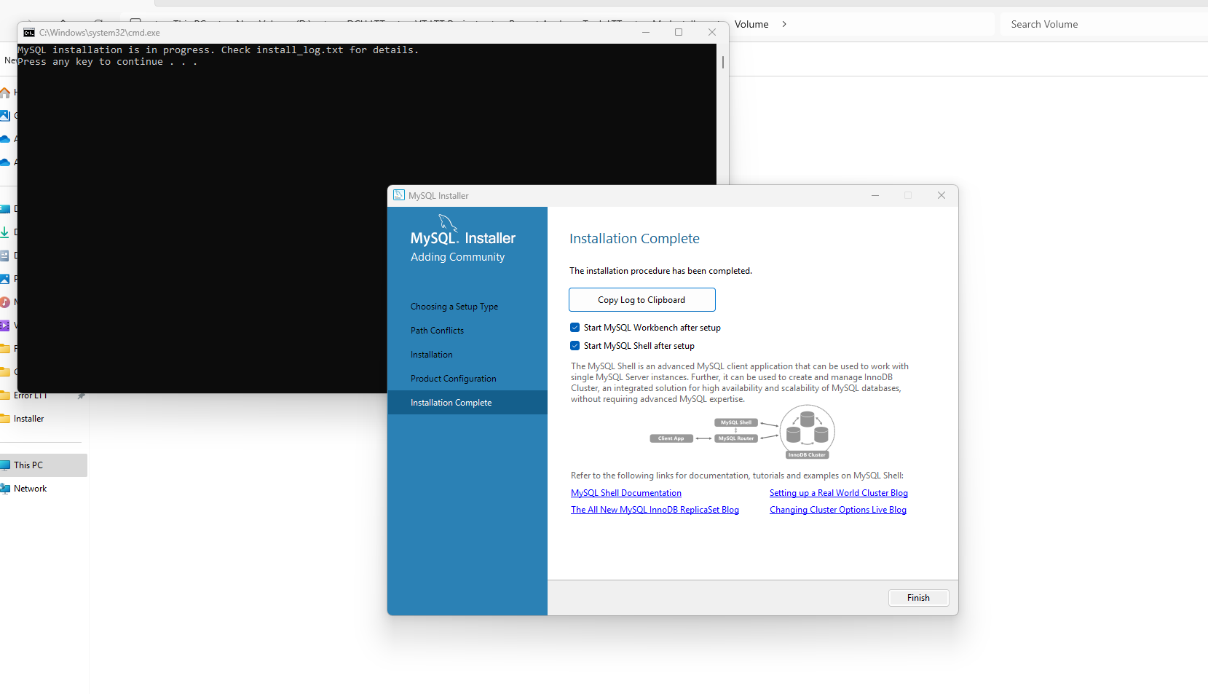

Post MySQL Installation Completion
- Go to Command prompt and press any button, this will launch the installation of MySQL ODBC

MySQL Connector ODBC Installation

MySQL Connector ODBC – Setup Wizard:
- Click on “Next”.
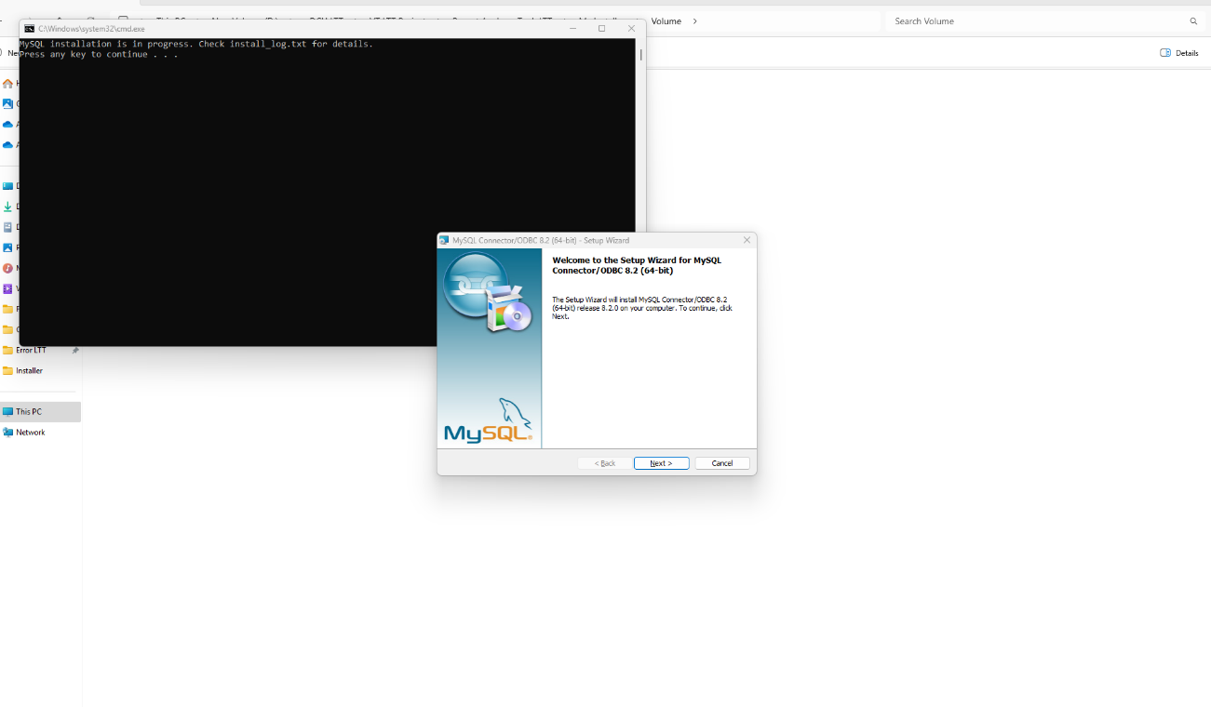

MySQL Connector ODBC – License Agreement:
- Tick the ‘” I Accept the terms in the license agreement and click the “Next”.

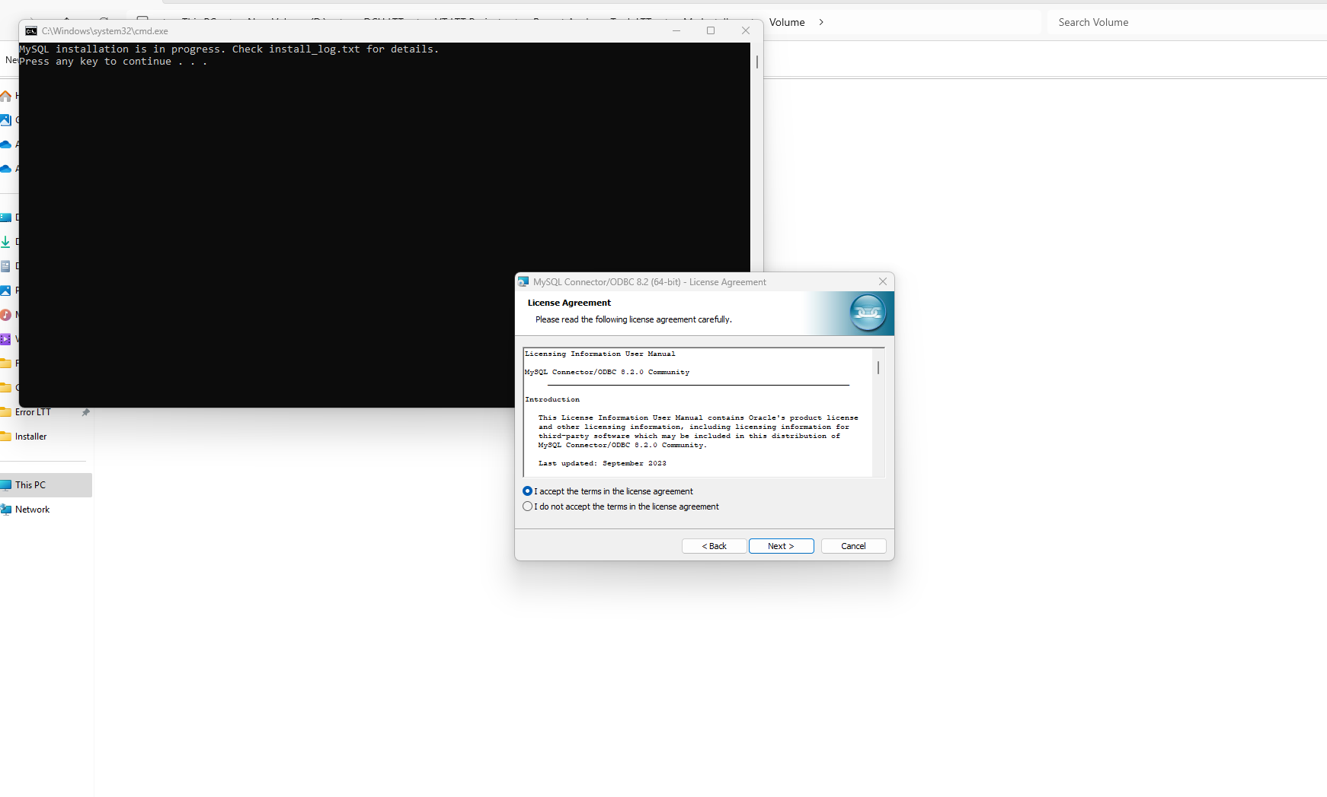
Tick the Button “Accept”

Click the Button “Next”

MySQL Connector ODBC – License Agreement:
- Tick the ‘” I Accept the terms in the license agreement and click on “Next”.

Tick the Button “Accept”

Click the Button “Next”

MySQL Connector ODBC – Setup Wizard- Setup Type:
- Click on “Next”.
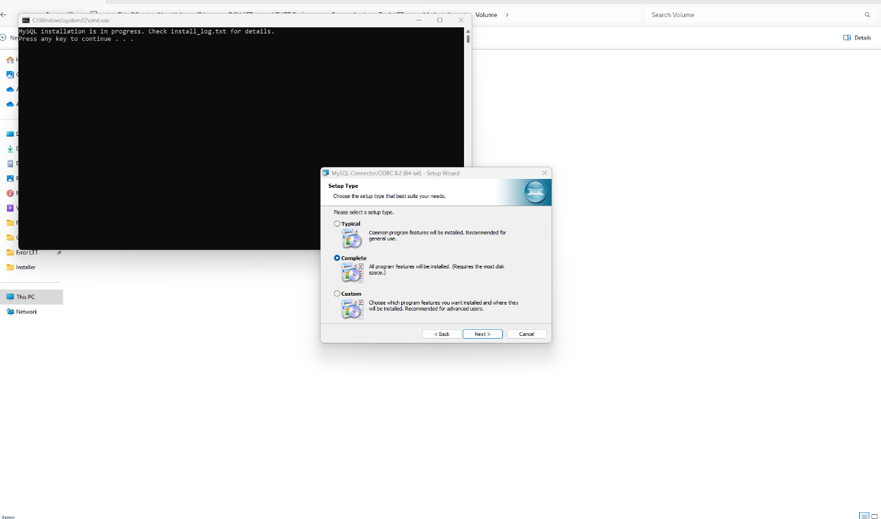
Tick the Button “Complete”

Click the Button “Next”

MySQL Connector ODBC – Setup Wizard Install:
- Click on “Install”.

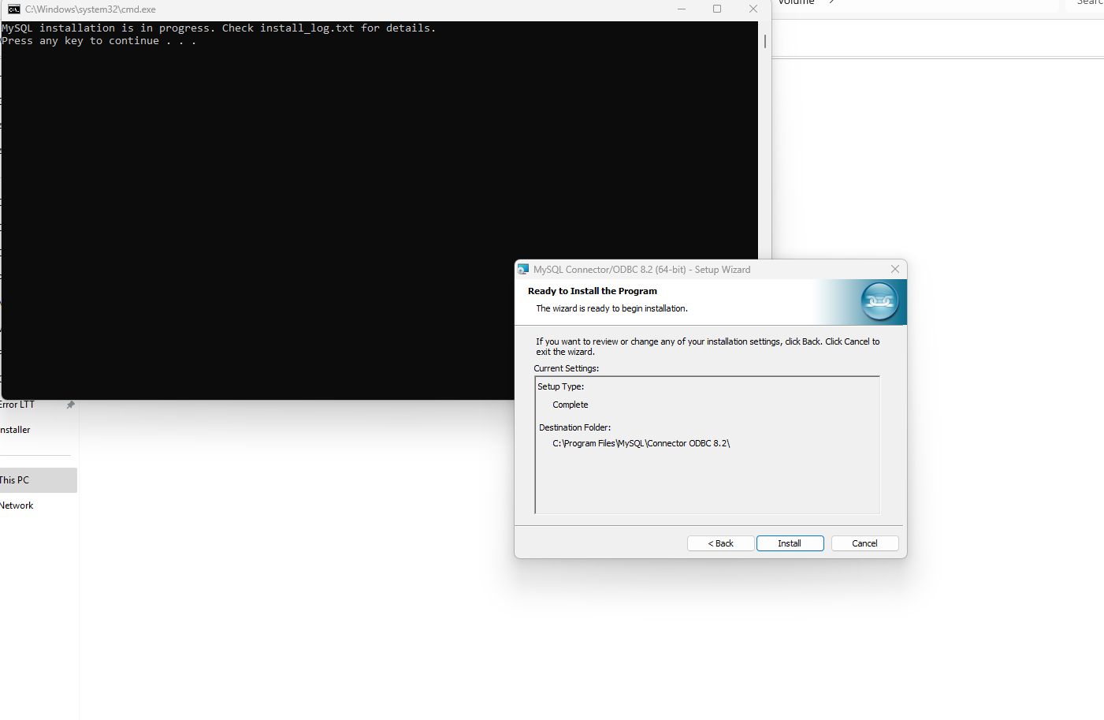

MySQL Connector ODBC – Setup Wizard-Completed:
- Click on “Finish”.
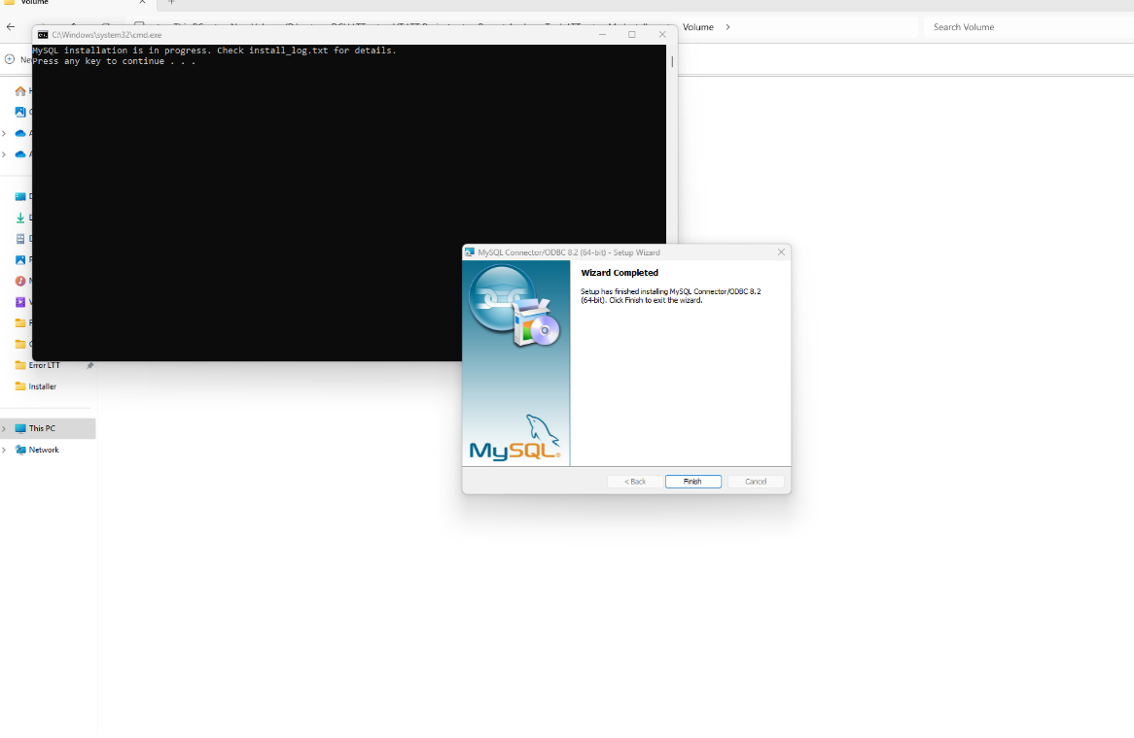
Click the Button “Finish”

Post MySQL ODBC Installation Completion
- Go to Command prompt and press any button, this will setup the ODBC connection

